KP3S - some improvements from personal operating experience.
After assembling the printer, before starting printing, it is necessary to conduct an external inspection of the mechanical assemblies, check the reliability of the screw connections, as well as the freedom of movement along the axes. Further recommendations for the completion of the printer units are purely advisory in nature and are not required to be repeated. Remember that design and software changes will void your warranty!
- Check that the printer axes are square. If necessary, adjust by loosening the screws securing the rail guides for the X, Y axes. Tighten the screws after alignment.
- Micro SD Card Slot Cover... thingiverse.com
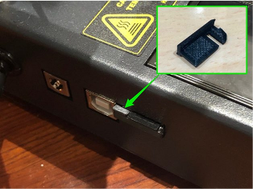
There is also an easier way to eliminate this disadvantage of the board mounting design. You just need to substitute plastic washers 2 mm thick under the board when fastening it with screws to the racks. By the way, the board is fastened with 3 screws.
- Refinement of the table:
- replacement of fastening screws with longer ones - countersunk screw M3 35mm.
- replacement of the table height adjustment springs with longer ones with sufficient elasticity, length 20 - 23 mm, inner diameter 4-5 mm. A little tip - a compression spring can be made from an extension spring. )
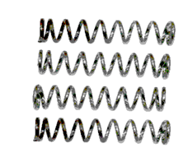
- thermal insulation, can be used heat-insulating material ALUFOM (PENOFOL) or similar, taking into account the maximum heating temperature of the table. Thickness 5-10mm, size 175x175mm.

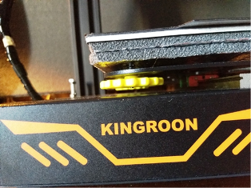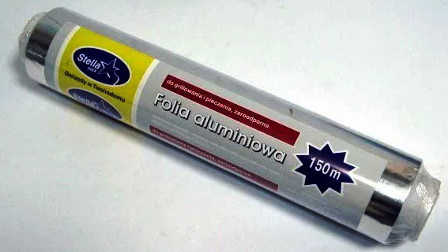
- To prevent the glass plate from sticking to the magnetic tabletop, place a sheet of aluminum foil (baking foil) between the glass and the magnet in the size of the table.
- finalizing the fastening of the wires going to the table. To reduce bending and tension, we fasten the wires through a gasket with a height of 6-8 mm.
- Fixing the bolt for limiting the actuation height of the limit switch of the Z axis with a lock nut M4.
- Adding an 8mm diameter metal ball to the base of the Z axis.
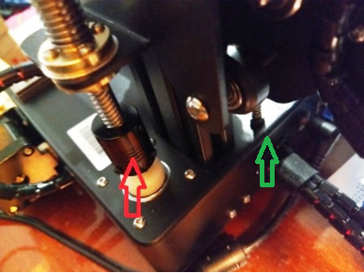
- Installation of brass spring nut anti-backlash 8mm thread pitch 2mm, on Z-axis (backlash-free nut for drive shafts THSL). We fasten the new nut to the existing nut on the shaft with 4 screws M3x10 mm. We control the smoothness and ease of movement along the entire length of the Z axis. If during installation there is a problem with movement, it is necessary to install a washer made of scrap materials between the iron corner and the anti-backlash nut. In my case, this is aluminum with a thickness of 0.4-0.5 mm.
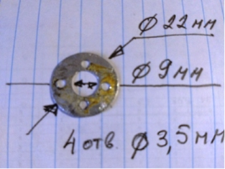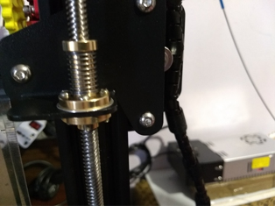
- Fixation of the upper end of the Z axis by bearing 608ZZ, which is installed in the holder of the aluminum profile plug.
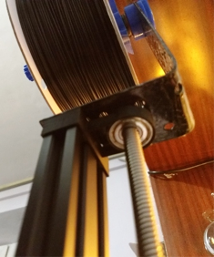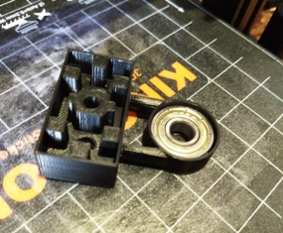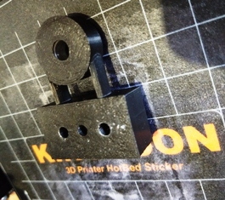

- Top mounting of the coil with a holder (40x300x2mm curved plate), mounted on top of the aluminum profile. Fastened with two M5 30mm screws. It is necessary to cut M5 threads in the profile. The holder itself is here3dtoday.ru - Filament spool holder on bearings with brake.

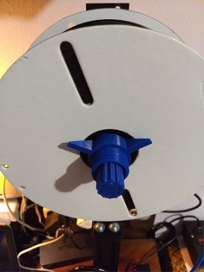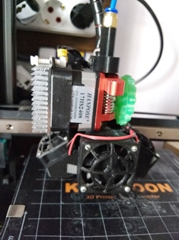
- Rebuilding the extruder E3D v5 for:
- higher fixation of the nozzle (we screw it all the way).
- winding with fum tape (3-5 turns) threads of the thermal barrier to a screw-in height of heating block.
- adding thermal paste KPT-19 to the holes for fixing the heater and temperature sensor.
- inserts of the heater and temperature sensor on the left side of the heating block of the extruderto reduce the visible length of the wires from the fans and extruder motor to the main wiring harness (this depends on the thread height during assembly).
- adding a silicone case heating block of the extruder.
- installation of double-sided blowing of the model. The model file is locatedhere... (fan connection is described below - item 15).
- replacement of the iron mesh of the fans - plastic.

We change motors NEMA 17HS4401 with a length of 40mm, weight 280g for 17HS3410 with a length of 34mm and a weight of 220g on the X and Y axes, on an extruder - NEMA 17HS2408 with a length of 28mm, weight 150g. This will make it possible to reduce the size and weight! We reduce the currents on the drivers and set the reference voltage of the driver modules of the new X and Y motors to 1V, for the extruder 0.7-0.8 V.

Add a visualizer handle to the extruder motor shaft.

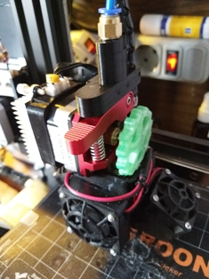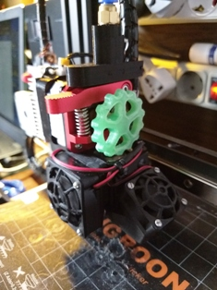

Install the blank cover on the screws securing the limit switches of the X Z axes. 3dtoday.ru - KP3S X, Z axis limit switches plug.
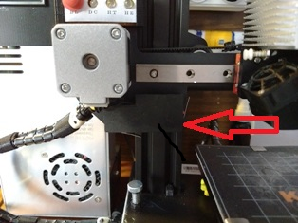

Modification of the 24V 15A power supply unit includes:

- installation of a radiator on a diode bridge.

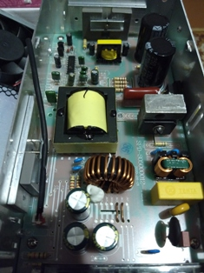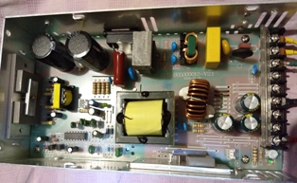

- strengthening of power circuits, if necessary (additional soldering of the printed circuit board).

- replacement of thermal paste of transistors and diode assembly of the power supply unit.

- adding at the input 220V varistor TVR10621 to the provided place ZNR1 on the printed circuit board of the power supply unit.

- adding varistor 472 to the board seat CY3.

- adding a 0.01 - 0.1 μF capacitor at the DC output to the C16 footprint.
- installation of a jumper, inductance and capacitor 47 uF 35V to ensure the operation of the second fan connector.
- replacement of the front panel of the power supply unit, alteration of the power switch, the socket of the network cable and the addition of indication of the output voltage and current - digital ampere-voltmeter 100 V 10 A DC...

We do not throw away the piece of iron remaining after the revision, but use it as a stand-holder. To do this, you need to drill 3 new mounting holes with a 4mm drill.
Note: the designation of elements on the ZL-360-24 board may vary.
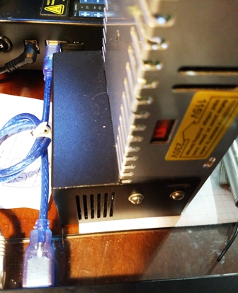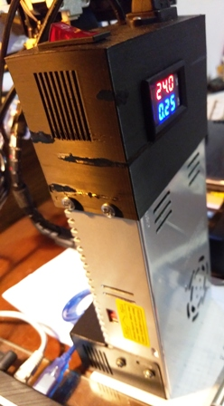
Note: the appearance of the board and the designation of the elements may vary depending on the manufacturer.

We reduce the noise of the blowing fans. The fans are powered by 24V. We have three fans in total:

- blowing of the radiator of the extruder 24V 30x30mm (main source of noise, switched on directly from the 24V power supply);

- blowing of 24V 30x30mm model (rotation speed is controlled by software - FAN socket on the board);

- blowing off the board and stepper motor drivers 24V 40x40mm, located inside the case on the bottom cover.

The solution to the problem is to use voltage step-down converters to supply a reduced 20V fan for blowing the extruder radiator and a 12V voltage for the cooling fan of the board and drivers. To accomplish this task, you must use 2 step-down voltage converters:DC-DC LM2596S for 20V voltage generation and MP2307 (MINI-360)to generate a voltage of 12V. ConverterThe MP2307 (MINI-360) is installed on a breadboard with connectors.We mount the converters inside the housing using screws or a mounting stand. The fan for blowing the board inside the case is changed to a 12-volt 40x40mm fan, and a 24V 40x40mm fan is used for blowing the extruder. It is installed in place of the standard one through the 30x40 fan mounting adapter.

Attention! The 12V and 24V fan connectors are mirror-symmetrical. (protection against incorrect connection).

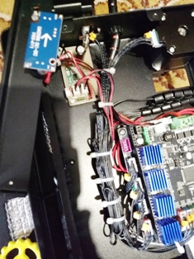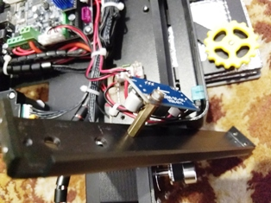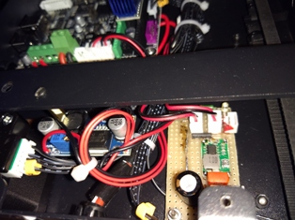

As a result, the operating noise of the printer is significantly reduced.

The KP3S printer model is blown by a 24V fan mounted on a metal duct. I propose to replace the metal with plastic with the addition of another fan creating a counterflow blowing.3dtoday.ru - Bilateral blowing of the KP3S model. The new part is fixed instead of the metal duct with the same screws. There is also an additional fastening with two M3x5mm screws on the right on the metal holder of the extruder. Mounting the fans (preferably together with the grille) - 8 screws М2Х17mm. For fastening with M3 screws, it is necessary to increase the diameter of the fastening holes. The blower fans of the model are connected in parallel with the power supply and connected to the FAN socket.

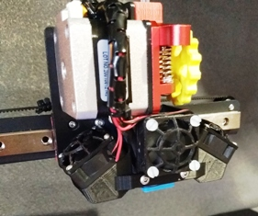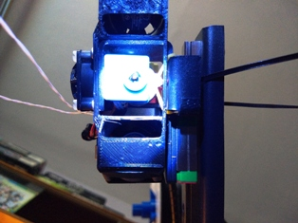

At the same time, (since we need to lay additional wires) we add table illumination on a bright LED (or a small piece of LED strip - 2 LEDs are enough). The LED is switched on through a resistor of about 2 kOhm (it can be selected taking into account the rated current of the LED), fixed to the left of the nozzle on the metal frame of the extruder with a nylon tie.

Add an indication board.

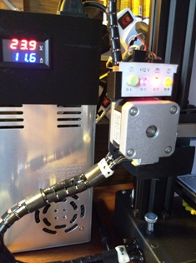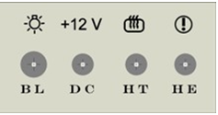

The board contains a button for turning on / off the backlight, an indicator of the presence of + 12V (after the converter), indicators for turning on the heating of the table and the extruder.

The board is installed in the slots of the holder mounted on a metal profile above the X-axis motor.

Improving cooling and air convection inside the case. We install a radiator on the mosfets using heat-conducting glueStars-922 Heatsink Plaster... We hide the wires of the distribution harness under the board.

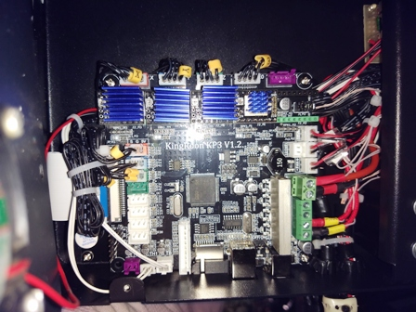

Separately about the installation of the power module MOSFET for powering the heated table. This revision was planned for implementation, but after conducting research on heating and visual inspection, and also considering that the current of the HY1403D mosfets is 42A at voltages up to 30V, it was recognized as inappropriate. It should also be noted that the printer consumes about 320 watts at full load. The main energy-consuming load is a heated table (11-12 A). The weak link in the power circuit is the power connector - the operating current when the table is heated exceeds the rated currentDC Power Jack. As a consequence, DC Power Jack operates in critical mode.

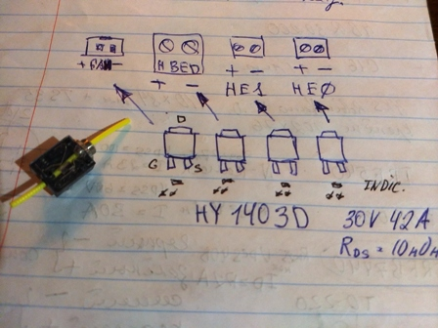

Sensor the end (presence) of the filament has a large size and poor attachment, which causes inconvenience during operation. In addition, inside the case there is a board on which the indication elements and the capacitor are soldered, which is redundant for this unit. I propose to reduce its dimensions by using onlymini microswitch for computer mouse KW10-Z0P with button, 3 pins without bar... (The same as in the old sensor). We print a case with a cover for it, solder the wires and use it.3dtoday.ru - KP3S filament end (presence) sensor.

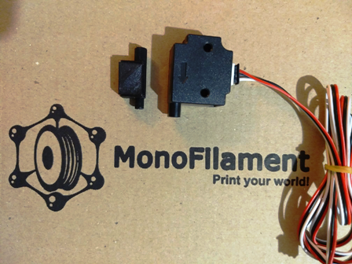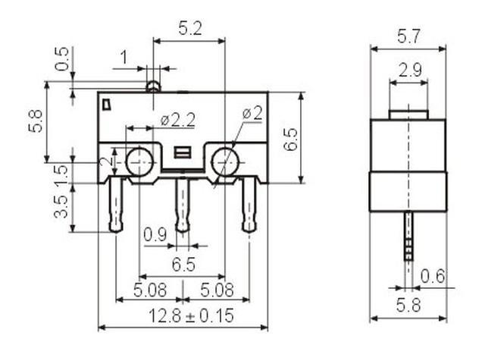

The photo shows a new and normal sensor for comparison.
The sensor can be combined with a Teflon tube holder.
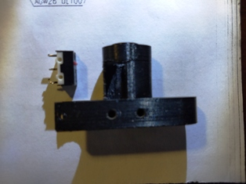
- Recommendations for protecting the MKS TMC 2225 driver against short circuits. Inspect your drivers! There are instances with a crookedly glued radiator, which can close the driver contacts (the radiator is very close to them). The solution to the problem is to install a plastic strip 0.8-1.0 mm thick between the radiator and the contacts on both sides to prevent short circuits.
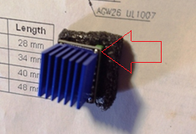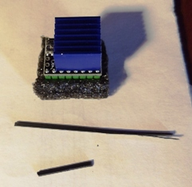

The illumination inside the case is implemented in the latest firmware based on Marlin bugfix-2.0.x by connecting a block of 3 12 V LEDs through a 1.5 kOhm damping resistance to the HE1 connector (second extruder). Brightness control is implemented as a separate menu item.


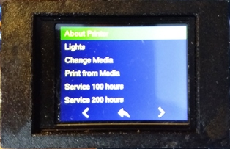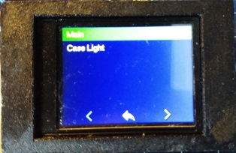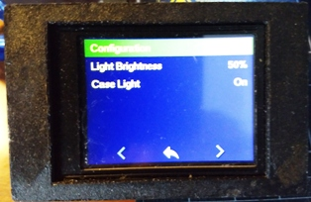
The file for the firmware can be downloaded here or here...
The firmware works flawlessly and without errors.
Note: firmware for non-inverted motors! (if the motor rotates in the other direction, the easiest way to fix everything is to mirror the contacts of the motor connection connector in the loop. Change the contacts when the power is off!) If there is no thread presence sensor, disable it in the menu.
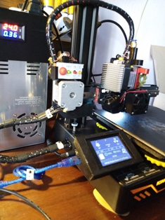

All improvements were applied by me after receiving information from various sources, as well as from personal operating experience and are not required to be repeated! Remember that you make all modifications and changes to the designunder your own responsibility.

Quality print for all!

